CMAS TC SPECIAL NEEDS DIVING
MEETING
Alicante October 2018
Spain

INTRODUCTION
WHAT IS THE DIFFERENCE BETWEEN “ADAPTED SPORTS” AND “INCLUSIVE SPORTS”?
“Adapted sport” is a sports activity that able to accept modifications to enable the participation of people with sensory, physical and intellectual disabilities.
“Inclusive sport” is when people with and without disabilities participate together. Therefore it is much more than “adapted sport”. Therefore, it goes beyond adapted sport, because it does not distinguish between athletes with and without disabilities when participating in a sports activity.
Scuba diving is a sport with an inclusive vocation; it has the ability to adapt to any condition, requires cooperation and coordination of all member in a team of divers.

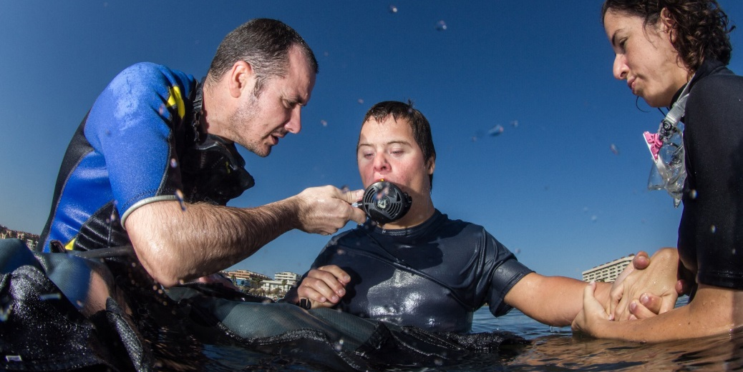
WHAT IS THE DIFFERENCE BETWEEN DISABLED DIVING AND SPECIAL NEEDS DIVING?
Historically, Disabled Diving has been exclusively concerned with the training of people with disabilities.
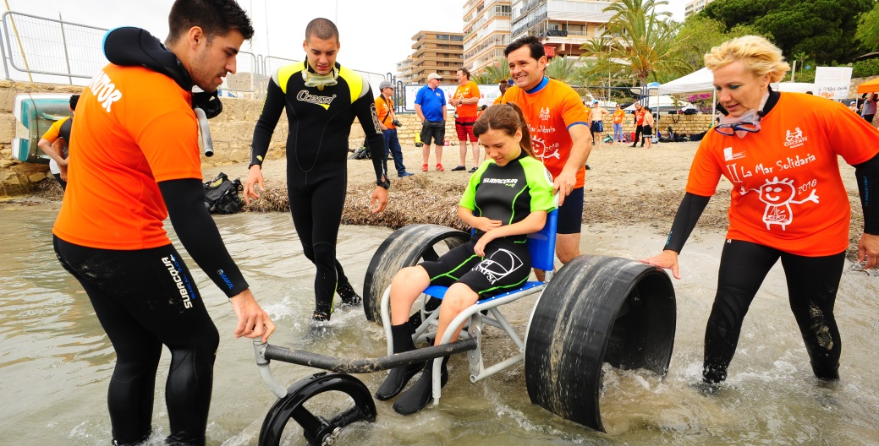

Special Needs Diving goes beyond the field of disabilities, assuming the concept of Functional Diversity in the broadest sense, and focusing on the idea of full inclusion.
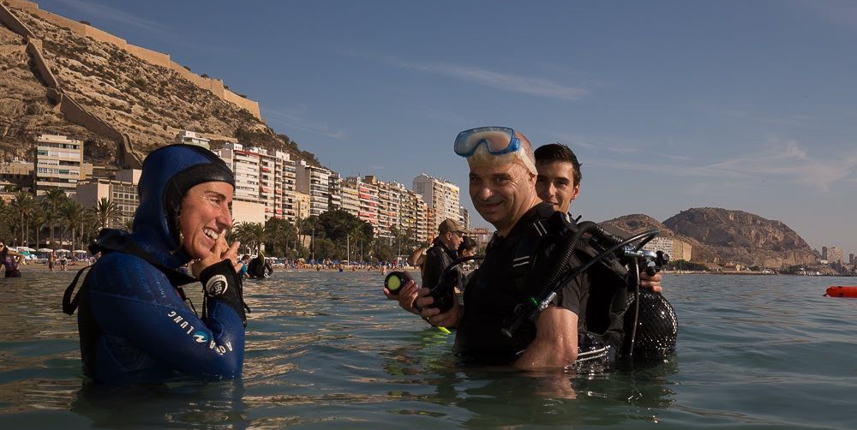
WHAT IS FUNCTIONAL DIVERSITY?
Functional diversity is a broad term that aims to eliminate the pejorative considerations of expressions such as disability, handicap, incapacity or deficiency, that are traditionally used to designate groups of people with disabilities.
The term was proposed in the Forum for Independent Living, in January 2005. It was later justified in publications by various authors as Functional Diversity, a new term for the struggle for dignity in the diversity of the human being or Model of diversity.
Functional diversity can also be understood as a phenomenon, a fact or a characteristic present in society that, by definition, affects all its members equally, because, during childhood and old age, all people are dependent.
It is a fact that in society, there are people with different abilities. A person will suffer changes and variations in his abilities throughout his life. Therefore, it is possible to affirm that, in society, there is functional diversity in the same way as cultural, sexual or generational diversity is observed.

WHAT IS SPECIAL NEEDS DIVING?
Taking into account the definition of inclusive sport, and the fact of not limiting the possibility of creating adaptations exclusively to address disability, CMAS TC introduces a new concept to talk about diving as an inclusive sport: Special Needs Diving.
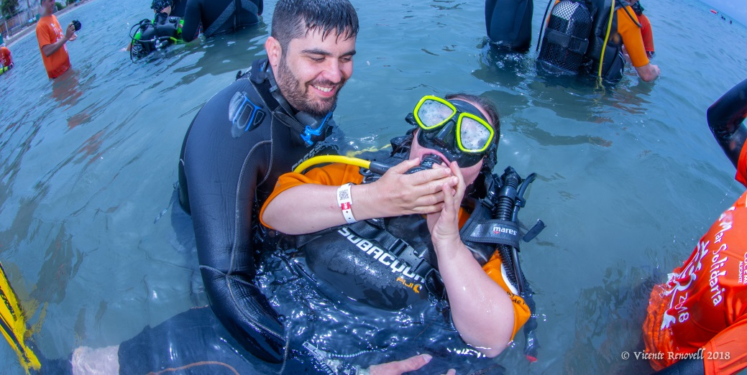
Special Needs Diving caters for training all persons outside the scope of standard CMAS diving programmes.
This group includes, but is not limited to:
- Senior citizens
- People in rehabilitation programmes
- People with sensory, physical and intellectual disabilities

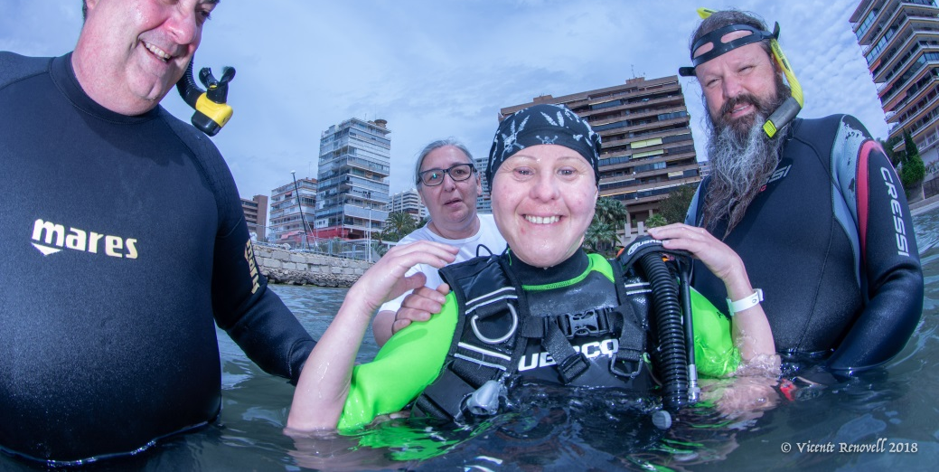

WHY DO WE NEED A SPECIFIC CMAS TRAINING PROGRAMME FOR INSTRUCTORS OF SPECIAL NEEDS DIVING?
CMAS has standards for Disabled divers, but it does not have a programme or specific materials to train CMAS diving instructors to deal with people with functional diversity.
Many CMAS Federations are interested in this field, but there is no available material to start up. The availability and distribution of this new material will open up new sectors to CMAS Federations and raise the level of Social Awareness/Respect for our organization.
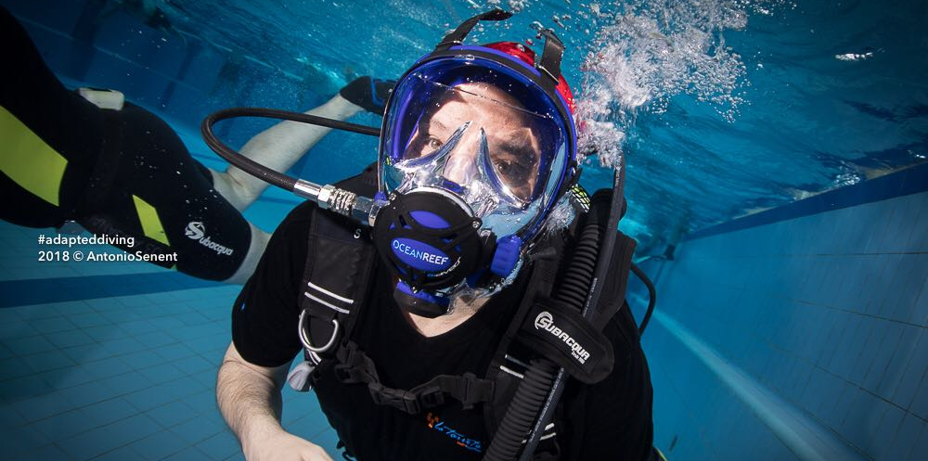
In addition, this could possibly provide CMAS Federations with access to certain funding and sponsorships (public and private) that are not within their scope at this moment.
Finally, CMAS as a leading World Diving Organization has a moral obligation to provide world-class diver training for all sectors of the population
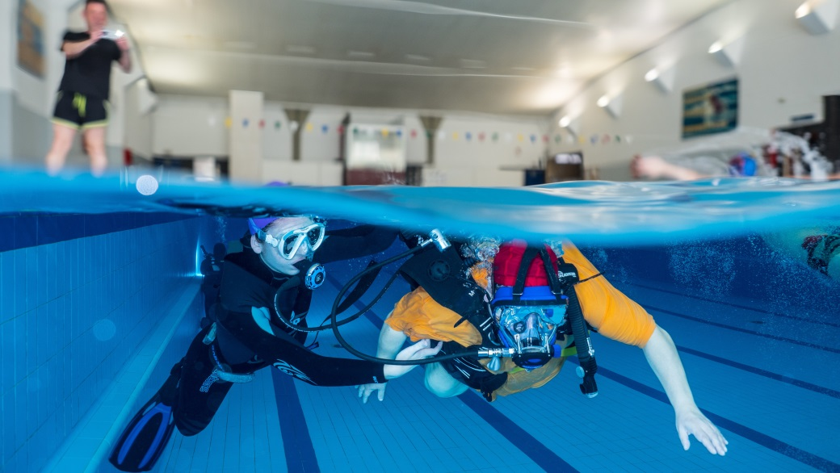
Therefore, it is necessary to develop a specific program, and the starting point will be this first International CMAS Meeting in which it is proposed to unify training criteria and to present new training contents developed within CMAS Technical Committee.

THE MEETING
OBJECTIVES OF SND CMAS MEETING
The general objectives for this meeting are:
- To share the different pedagogical approaches that have been developed in different CMAS countries during the training of instructors, following the current CMAS Disabled Diving Standards
- To set up an international framework where different CMAS Disabled Diving Instructors/Teams or CMAS Special Needs Diving Instructors/Teams that currently are working in different CMAS Federations can exchange information and knowledge and are interested in joining this meeting.
- To present latest advances within the field of training of instructors of Special Needs Diving that are being developed in the CMAS TC with the designated working group.
- Prepare the first document of conclusions of the proposals presented during the meeting.
DATES AND VENUE
CMAS Special Needs Diving meeting is scheduled to take place from 19th to 21th of October. The venue chosen for the event will be the University of Alicante, in San Vicente del Raspeig (Alicante, SPAIN).
This will be the second time that the University of Alicante has collaborated with the CMAS Technical Committee to organize an event. CMAS TC held a meeting in the University of Alicante in September 2017.
TARGET AUDIENCE
First of all, the meeting is mainly for CMAS Diving Instructors/Teams who are involved or interested in starting up in CMAS Special Needs Diving.
It is also recommended for scuba divers with adapted diving speciality (Disabled Diver Assistant) who want to know new areas of development for their skills as Diver Assistants.
Finally, this meeting is also recommended for students and University professors of Physical Activity and Sports Sciences Degree or Teaching and Special Education Degree
MAIN TOPICS PLANNED FOR THE SPECIAL NEEDS DIVING CMAS MEETING
According to the general objectives described, these are the issues to be addressed:
- Presentations of projects and initiatives of the different CMAS Federations/Countries related to disabled diving training.
- Conference on the concept of functional diversity to define CMAS Special Needs Diving.
- Conference / workshop on Alternative and Augmentative Communication Systems.
- Presentation of the CMAS Technical training programme for Instructors on Special Needs Diving.
- Presentation of tools for the development of Special Needs Diving projects.
- Conference on Ethics applied to Special Needs Diving.
- Workshop on pool activities for SND.

PROPOSED PROGRAMME
Fryday, October 19, 2018
10:00h - 16:00h Reception in Villa Universitaria and delivery of documents and accreditations.
18:00h - 19:30h Official presentation of the SND CMAS Meeting with the intervention of authorities:
- University of Alicante
- Local authorities
- Spanish Underwater Federation (FEDAS)
- World Underwater Federation (CMAS)
19:30h - 20:30h Welcome cocktail
21:30h Dinner
Saturday, October 20, 2018 (morning)
09:00h - 09:45h Presentation of projects and initiatives, country 1 (pending confirmation).
09:45h - 10:30h Presentation of projects and initiatives, country 2 (pending confirmation).
10:30h - 10:45h Break
10:45h - 11:30h Presentation of projects and initiatives, country 3 (pending confirmation).
11:30h - 12:15h Presentation of projects and initiatives, country 4 (pending confirmation).
12:15h - 13:00h Presentation of projects and initiatives, country 5 (pending confirmation).
13:30h - 15:30h Lunch
Saturday, October 20, 2018 (afternoon)
16:00h - 16:45h Conference on Functional Diversity.
16:45h - 17:30h Presentation of SND CMAS training programme for instructors.
17:30h - 18:00h Break
18:00h - 19:15h Workshop on Alternative and Augmentative Communication Systems.
19:15h - 20:00h Presentation of tools for the development of Special Needs Diving projects.
21:30h Special dinner at Real Club de Regatas de Alicante

Sunday, October 21, 2018
09:00h - 10:00h Workshop on pool activities.
10:00h - 10:30h Break
10:30h - 11:30h Conference on Ethics applied to Special Needs Diving.
11:30h - 12:15h Conclusions of the CMAS Technical Committee and presentation of next objectives.
- D. Flemming Holm, President of CMAS Technical Committee
12:15h - 13:00h Closure of the Meeting with the intervention of:
- D. Manuel Palomar, Rector de the University of Alicante
- Dña. Anna Arzhanova, President of CMAS
The programme is currently under review and may have minor changes in the structure.
ENROLLMENT
The enrollment fee is €250 per person.
Students and staff of the University of Alicante will have a reduced enrollment fee.
The enrollment will soon be available until September 21 on the website of the University of Alicante.

ORGANIZATION
Accommodation
Accommodation during the meeting will be at the free choice of the participants.
However, the University of Alicante has a collaboration agreement with "Villa Universitaria", a student residence that has an area specifically dedicated for accommodating people during meetings and other events held at the University of Alicante, with special prices. In addition, it is located 200m from the Campus of the University of Alicante.
Information and delivery of documents and credentials
The people accommodated in "Villa Universitaria" will have an information service by the group of volunteers of the University of Alicante.
On arrival to “Villa Universitaria”, during check-in, volunteers of the University of Alicante will deliver documents and credentials for the meeting.
People who do not stay in "Villa Universitaria" will receive the documentation and credentials 30 minutes before the start of the meeting in the hall of the conference room.
Language during the meeting
The congress will have a simultaneous English-Spanish translation service.
Meals
Scheduled meals during the meeting will be included in the registration fee for the event:
- Friday: Welcome cocktail and dinner
- Saturday: Luch and Special Dinner
Transfer Airport-University-Airport
The transfer between the Airport and the University will be organised for all CMAS representatives and speakers participating in the event.
Transfer University - Real Club de Regatas de Alicante – University
The special dinner on Saturday is planned at the Real Club de Regatas de Alicante. There will be a special bus service available to transfer all the participants of the meeting to this place.

MORE INFORMATION AND ORGANIZATION CONTACT
Technical Committee
Kelly McGinn
CMAS Technical Diving Director
Kellymcginn@hotmail.com
(+34) 690 93 06 93

UNIVERSITY OF ALICANTE
Enrique Díaz Bernabé
ASUA - Actividades Subacuáticas Universidad de Alicante
asua@ua.es
(+34) 690 67 67 53

(Romañach & Lobato, Diversidad Funcional, nuevo término para la lucha por la dignidad en la diversidad del ser humano, 2005)
(Romañach & Palacios, El modelo de la diversidad. La Bioética y los Derechos Humanos como herramientas para alcanzar la plena dignidad en la diversidad funcional, 2006)

